**PRACTICAL 5**

**Title: - Php Form Handling Cookie Management**

## PRACTICAL -5

**Q-1) Use HTML form created in practical -1. Enter respective data into each**

## and using the post method pass the data and display the data to the Data.php page on click on submit button.

### L5P1.PHP

<!doctype html>

<html>

<head>

<title>Registration Form</title>

<style>

input {

width: 100%;

}

</style>

</head>

<body>

<form method="post" action="./l5p1data.php">

<table>

<tr>

<th><h1>Registration Form</h1></th>

</tr>

<tr>

<td><input type="text" name="name" placeholder="Enter username"></td>

</tr>

<tr>

<td><input type="password" name="pass" placeholder="Enter password"></td>

</tr>

<tr>

<td><input type="text" name="branch" placeholder="Enter branch"></td>

</tr>

<tr>

<td><input type="text" name="contact" placeholder="Enter contact no"></td>

</tr>

<tr>

<td><input type="submit" name="sbt" value="Register"></td>

</tr>

</table>

</form>

</html>

### Data.php

<?php

if(isset($_POST['sbt'])) {

$name = $_POST['name'];

$pass = $_POST['pass'];

$contact = $_POST['contact'];

$branch = $_POST['branch'];

echo "<h2>";

echo "Name is $name <br>";

echo "Password is: $pass <br>"; echo "Contact is: $contact <br>"; echo "Branch is: $branch <br>"; echo "</h2>";

}

?>

**OUTPUT**

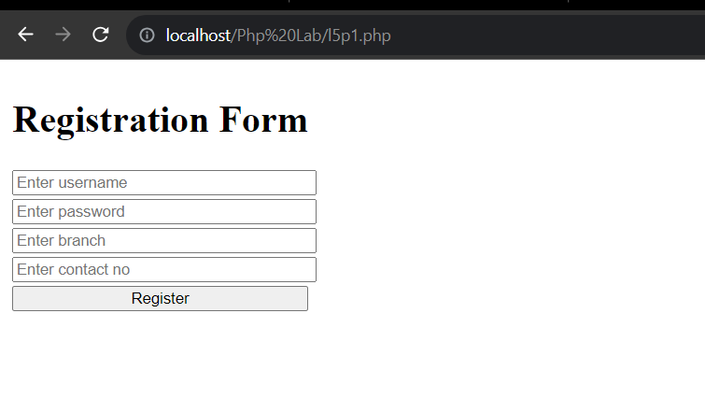

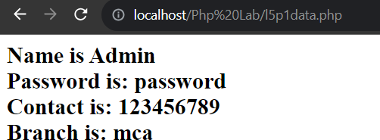

**Q-2) Create a HTML form that reads 2 numbers and has 4 buttons for**

## operation: - Add, Difference, Product. Based on the button clicked by the user the result should be displayed as output.

**CODE:**

<!DOCTYPE html>

<html lang="en">

<head>

<meta charset="UTF-8">

<meta name="viewport" content="width=device-width, initial-scale=1.0">

<title>Document</title>

</head>

<body>

<form method="post" action="./l5p2data.php">

<label>Enter no 1: </label>

<input type="number" name='no1'/></br>

<label>Enter no 2: </label>

<input type="number" name='no2'/></br> </br> <br>

<button name='add'>Addition</button>

<button name='sub'>Substraction</button>

<button name="mul">Multiply</button>

<button name="div">Division</button></br>

<tr>

<td><input type="Submit" name="submit" value="Submint"/></td>

</tr>

</form>

</body>

</html>

**DATA.PHP**

<?php

$ans1=$no1+$no2;

echo "Addition is: ". $ans1;

}

if(isset($_POST['sub']))

{

$no1=$_POST['no1'];

$no2=$_POST['no2'];

$ans1=$no1-$no2;

echo "Subtraction is: ". $ans1;

}

if(isset($_POST['mul']))

{

$no1=$_POST['no1'];

$no2=$_POST['no2'];

$ans1=$no1*$no2;

echo "Multiplication is: ".$ans1;

}

if(isset($_POST['div'])){

$no1=$_POST['no1'];

$no2=$_POST['no2']; if($no2 != 0) {

$ans1=$no1/$no2;

echo "Division is: ".$ans1;

} else {

echo "Division by zero is not allowed.";

}

}

?>

# OUTPUT

# 

# 

# 

## Q-3) Create an HTML form which takes 10 numbers (comma separated) and redirect control to findsum.php create a Php script which stores the numbers into an array and displays the total of the array.

### CODE:

<!DOCTYPE html>

<html lang="en">

<head>

<title>Student result</title>

<style>

input {

width: 100%;

}

</style>

</head>

<body>

<form method="POST" name ="frm" action="l5p3data.php">

<table align="center">

<tr>

<th>Sum No</th>

</tr>

<tr>

<td><input type="text" placeholder="Enter 10 no" name="no" required></td>

</tr>

<tr>

<td><input type="Submit" name="sbt" value="Submit"></td>

</tr>

</table>

</form>

</body>

</html>

### Data.php

<?php extract($_REQUEST); if(isset($sbt))

{

$arr = explode(",", $no); // Changed ", " to "," echo("No is : <br>");

$result = array_sum($arr); foreach($arr as $ele)

{

echo($ele . "<br>");

}

echo("<br>Sum is : $result<br>");

}

?>

**output**

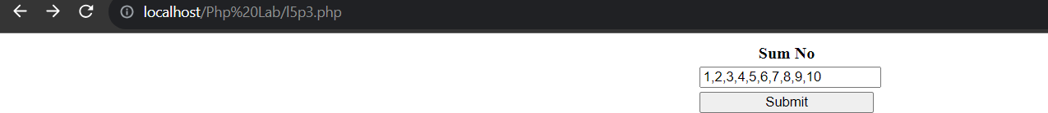

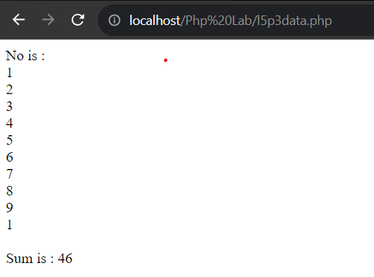

## Q-4) Create a page signin.php, which takes the username, age, city from user on click of submit button set the cookies values for each and display values on next page view.php

### CODE:

<!DOCTYPE html>

<html lang="en">

<head>

<meta charset="UTF-8">

<meta name="viewport" content="width=device-width, initial-scale=1.0">

<title>Student result</title>

<style>

input

{

width: 100%;

}

</style>

</head>

<body>

<form method="POST" name ="frm" action="l5p4data.php">

<table align="center">

<tr>

<th>Result</th>

</tr>

<tr>

<td><input type="text" placeholder="Enter user name" name="uname" required></td>

</tr>

<tr>

<td><input type="number" placeholder="Enter age" name="age" max="100" min="0" required></td>

</tr>

<tr>

<td><input type="text" placeholder="Enter city" name = "city" required></td>

</tr>

<tr>

<td><input type="Submit" name="sbt" value="Submit"></td>

</tr>

</table>

</form>

</body>

</html>

**DATA.PHP**

<?php

extract($_REQUEST); if(isset($sbt))

{

setcookie("uname", $uname);

setcookie("age", $age); setcookie("city", $city);

print("User name is :". $_COOKIE['uname']. "<br>");

print("Age is :". $_COOKIE['age']. "<br>");

print("City is :". $_COOKIE['city']. "<br>");

}

?>

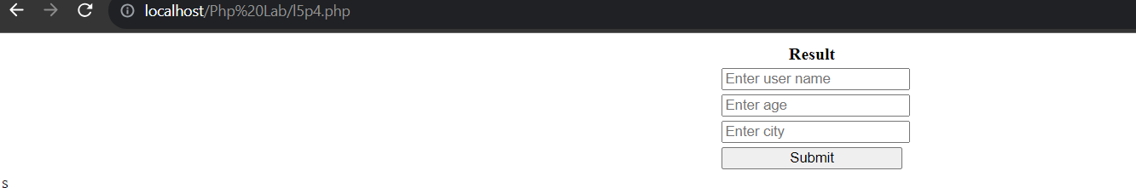

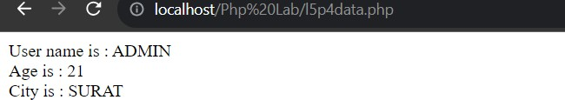

## Q-5) Create a Php page which takes the student’s name and marks of three subjects from the user. It stores all information as cookies and displays all

**information on the next page.**

**CODE:**

<!DOCTYPE html>

<html lang="en">

<head>

<meta charset="UTF-8">

<meta name="viewport" content="width=device-width, initial-scale=1.0">

<title>Document</title>

<style>

input

{

width: 100%;

}

</style>

</head>

<body>

<form method="POST" name ="frm">

<table align="center">

<tr>

<th>Result</th>

</tr>

<tr>

<td><input type="text" placeholder="Enter name" name="fname" required></td>

</tr>

<tr>

<td><input type="number" placeholder="Enter 1st subject mark" name="m1" max="100" min="0" required></td>

</tr>

<tr>

<td><input type="number" placeholder="Enter 2nd subject mark" name="m2" max="100" min="0" required></td>

</tr>

<tr>

<td><input type="number" placeholder="Enter 3rd subject mark" name="m3" max="100" min="0" required></td>

</tr>

<tr>

<td><input type="Submit" name="sbt" value="Submit"></td>

</tr>

</table>

</form>

</body>

</html>

<?php extract($_REQUEST); if(isset($sbt)) {

setcookie("fname", $fname); setcookie("m1", $m1); setcookie("m2", $m2); setcookie("m3", $m3);

}

## DATA.PHP

<?php

if(isset($_COOKIE))

{

echo("Name is : " . $_COOKIE['fname'] . "<br>");

echo("1st sub mark is : " . $_COOKIE['m1'] . "<br>");

echo("2nd sub mark is : " . $_COOKIE['m2'] . "<br>");

echo("3rd sub mark is : " . $_COOKIE['m3'] . "<br>");

}

?>

**OUTPUT**

